# Internet of Things (IoT):

The internet of things, or IoT, is a system of interrelated computing devices, mechanical and digital machines, objects, animals or people that are provided with unique identifiers ([UIDs](https://internetofthingsagenda.techtarget.com/definition/unique-identifier-UID)) and the ability to transfer data over a network without requiring human-to-human or human-to-computer interaction.

A [thing](https://internetofthingsagenda.techtarget.com/definition/thing-in-the-Internet-of-Things) in the internet of things can be a person with a heart monitor implant, a farm animal with a [biochip transponder](https://internetofthingsagenda.techtarget.com/definition/injectable-ID-chip-biochip-transponder), an automobile that has built-in [sensors](https://whatis.techtarget.com/definition/sensor) to alert the driver when tire pressure is low or any other natural or man-made object that can be assigned an IP address and is able to transfer data over a network.

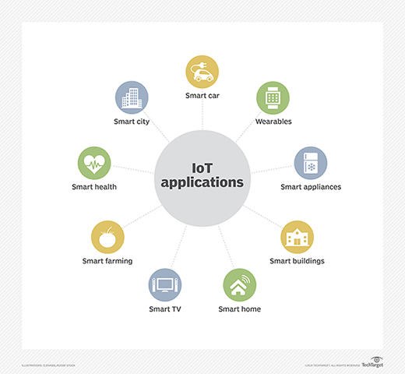

Figure 1 : IoT applications

Margaret Rouse. Internet of things (IoT) <https://internetofthingsagenda.techtarget.com/definition/Internet-of-Things-IoT> [accessed July 9, 2019].

*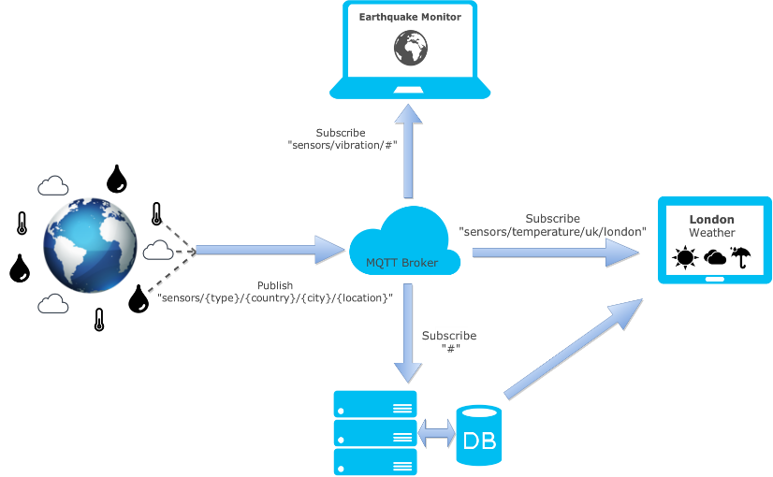Example:*

Figure 2 : Example of a sensor on Baker Street in London

Richard Webb. A Brief, but Practical Introduction to the MQTT Protocol and its Application to IoT. [published March 23, 2016]. <https://zoetrope.io/tech-blog/brief-practical-introduction-mqtt-protocol-and-its-application-iot/> [accessed July 9, 2019].

# IoT in product lines:

A **product line** is a group of products that a company creates under a single brand. The products are similar and focus on the same market sector. Maybe their function or channel distribution are the same or similar. Perhaps their physical attributes, prices, quality, or type of customers are the same. We call the activity **product lining**.

A company can have more than one product line. The number of product lines it has reflects its resources, i.e., how powerful it is.

Product line numbers might also show the other players in the marketplace how competitive the company is. In this context, the term [‘marketplace’ means the same as ‘market’](https://marketbusinessnews.com/financial-glossary/marketplace) in its abstract sense.

What Is A Product Line? Definition And Examples.<https://marketbusinessnews.com/financial-glossary/product-line/>.[accessed July 9, 2019].

The integration of IoT into product lines allows more effective control of product parameters and offers considerable time and cost savings through wireless control.

*Example:*

For example, Ninja Tech recently showcased a new martial arts gadget that allows consumers to monitor their health during physical workouts. **The product fits the overall Ninja Tech product line of spy gear, computers, tablets, phones, etc.**

Jennifer Lombardo. Types of New Products: New Product Lines, Product Improvements & More Chapter 8/Lesson 2. <https://study.com/academy/lesson/types-of-new-products-new-product-lines-product-improvements-more.html>.[accessed July 9, 2019].

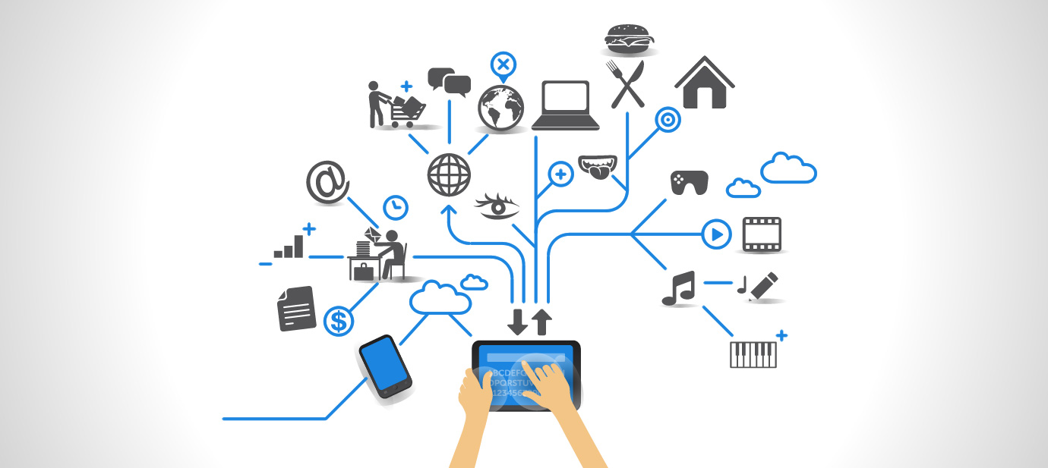

Figure 3: IoT overview

# Some key words useable for the review:

* SPL
* IoT
* Software
* Sensors / Devices / Controllers
* Gateways / Connectivity / Edge Computing
* Cloud Infrastructure (public, private, hybrid, managed)
* Data Ingestion
* Data Analysis
* IoT Applications
* Business Processes and People
* Internet of Things
* Wearables
* M2M
* Safety
* Security
* Software design description (SDD)
* Unified Modeling Language (UML)
* Semantic
* Industrial automation
* Industrial Cyberphysical